Based on the original works presented in Chickadel et al., (2003)
Elora M H Oades
Department of Civil Engineering
Queen’s University
Canada
Video-Currents-Toolbox V2.0
CIRN
November 2024

Toolbox Contents
videoCurrentsDemoNew.m
Start here. This demo will walk you through the toolbox and generate figures to visualize results.
vidCurrentsParams.m
The params file, where you can specify details about the input and output data.
See “Quick Start Guide” below.
[sampleStack, timex] = loadVbarRawFile(fileSearchPath, searchDate, transects)
Loads the timex image variables (x, y, Ip) and vbar files (sampleStack) from the folder (fileSearchPath), and which match the searchDate (format: datetime) at any number of desired transects.
[inpDat] = prepDataForInput(sampleStack,params)
This function reformats the vbar data for analysis, according to the params file. For each camera, the data is projected onto a regularly spaced grid and the mid-point of analysis windows are identified (yCenters).
[params] = radonVbarDir(inpDat, params, plotFlag)
With this optional function, the user can automatically identify the dominant direction of the alongshore current, which determines the bounds of the search velocity (vBounds).
[vcTable] = vcTableGen(inputDat, params, xLocation)
This function is used to generate a table for each of the indicated xLocations. This function calls on the original function, videoCurrentGen, to calculate the alongshore velocity of each analysis window.
dataStruct = videoCurrentGen(stack,time,xy,vB,fkB,tWin,tStep,varargin)

Introduction
Purpose
The Video Currents Toolbox enables the quantification of longshore surf-zone currents from video imagery

Background
Chickadel, C.C., Holman, R.A. and Freilich, M.H., (2003). An optical technique for the measurement of longshore currents. Journal of Geophysical Research: Oceans, 108(C11).
- Uses 1D video data of foam drift to estimate longshore surface currents.
- Converts pixel data into velocity estimates with a model fit for accuracy.
- Provides the foundation of the toolbox, videoCurrentGen.
Oades, E.M., Mulligan, R.P., Palmsten, M.L., Penko, A.M, Elgar, S., Raubenheimer, B. (In-Prep). An improved algorithm for processing optical remote sensing observations of wave-driven alongshore currents informed by non-hydrostatic numerical modelling. In preparation for submission to Journal of Geophysical Research: Oceans.
- Applies the original algorithm along the length of all available pixel transects and filters them using a new quality control metric
- Automatic current direction detection to define velocity search bounds
System Requirements
- MATLAB R2024b
- Optimization Toolbox
- Signal Processing Toolbox
- Image Processing Toolbox
- Statistics and Machine Learning Toolbox

Input Data
This toolbox is configured to use vbar input files with the following naming convention:
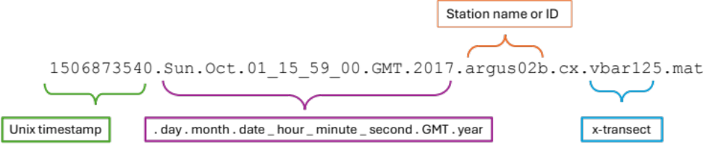
That contains the following variables:
CAM | 15001 x 1 uint8 | Camera number
*GAIN | 6 x 2048 double | Camera gain
*Name | vbar125 | File name where 125 = x-transect)
RAW | 2048 x 15001 uint8 | Pixel intensity (0 – 265)
SHUTTER* | 6 x 2048 double | Camera shutter speed at each timestep
stats* | 1x1 struct | Collection statistics
T | 1 x 2048 | Time in epoch
version* | ‘2016-08-19 packed’ | Collection version
XYZ | 15001 x 3 double | Pixel position (z = 0)
*These variables are not required to run videoCurrentsDemoNew

Output Data
meanV | OCM guess at the mean current for the timestep
t | time index for meanV
ci | the 95% conf. interval around meanV
cispan | the width of ci
prob | the probability of the model fit
QCspan | the 95th percentile minus the 50th percentile of the timestack histogram, used to measure the amount of video "texture"
stdV | the width (std. dev.) of the energy in velocity spectrum
vAngle | orientation of the pixel array (radians)
SNR | Signal to noise ratio: A_{foam} / A_{noise}
meanI | Average value of pixel intensity (I)
stdI | Standard deviation of the pixel intensity (I)

Quick Start Guide
Start by opening the code “videoCurrentsDemoNew.m” & edit the parameters listed in “vidCurrentsParams.m”.
Variable | Definition | Default Values | Units
yLims | Alongshore search bounds [yMin yMax] | [0, 1100] | m
transects | Cross-shore vbar transect locations | [125, 150, 175, 200, 225] | [m]
delY | Resolution of gridded pixels in the alongshore direction | 0.2 | [m]
tileSize | Length of analysis window in alongshore-direction | 10 | [m]
searchDate | Datetime of search data | 17-Oct 2017 15:59:00 | datetime
fSample | Image sampling frequency | 2 | Hz
tWindow | The time length of the analysis window | 64 | s
tStep | Temporal resolution of the output estimates | 32 | s
vBounds | Search limits for alongshore velocity | [vMin vMax] empty | m/s
radonCamNum | The camera ID from which the velocity direction (+ or -) will be calculated | 3 | Camera #
fkBounds | Frequency, wavenumber bound | [0.015 0.5 0.02 0.5] | Hz, 1/m
The input parameters are as follows:

Figures
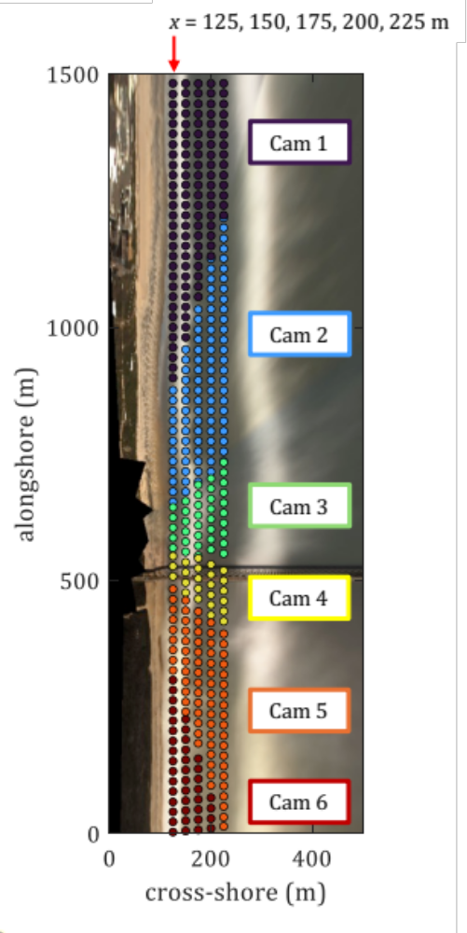
Figure 1: A sample timex overlayed showing all 5 (five) vbar pixel transects at x = 125, 150, 175, 200, and 225 m.
In the video-currents-Toolbox, camera data are processed separately (regardless of how many cameras exist within the system.
In this figure, the “tileSize” is 20 m, and each point represents the center of the analysis window (tile).
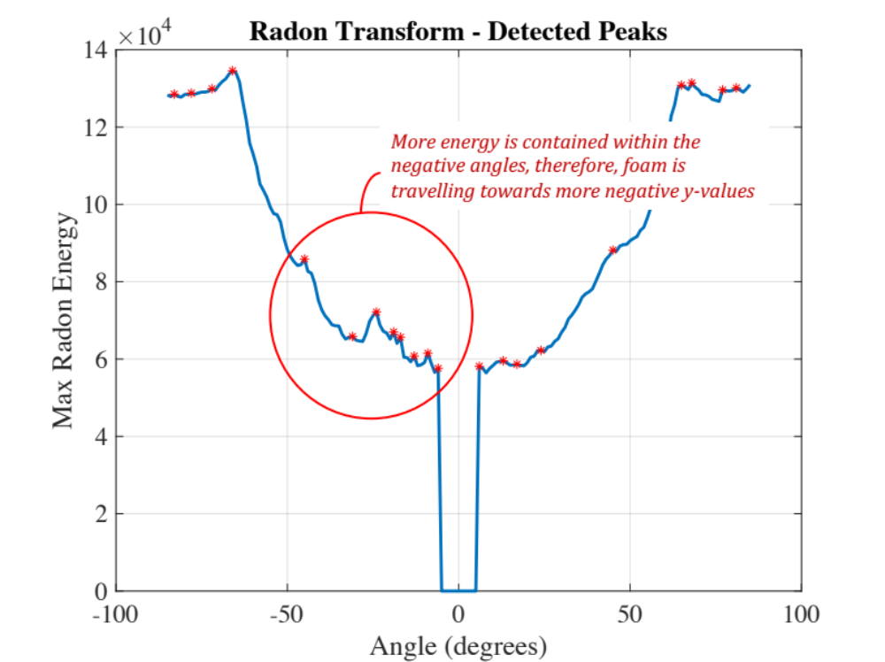
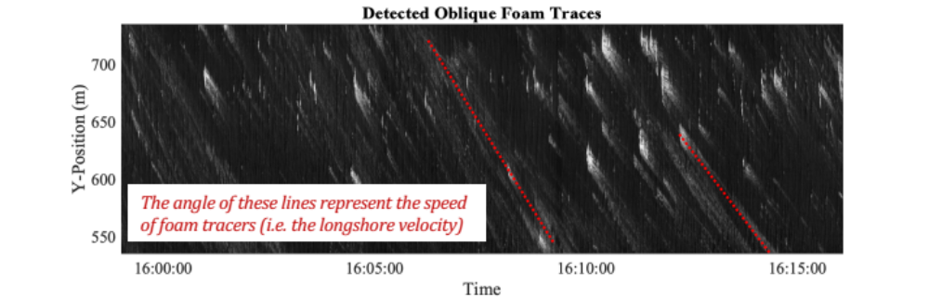
Figure 2: Sample ‘vbar’ timestack from camera 3 over 17-minutes illustrating the oblique lines left from residual foam.
This figure is generated in radonVbarDir when plotFlag = 1.
Figure 3: Sample maxima of the Radon transform applied to the timeseries in Figure 2, which is used to identify the dominant foam tracer direction.
This figure is generated in radonVbarDir when plotFlag = 1.

